CLOUD COMPUTING

PERSONAL BLOG ON IBM CLOUD STATIC WEB APPLICATION

Surya. K(420721104051)

Introduction:

In this Document, a dedicated space where I will embark on a journey through the fascinating world of IBM Cloud Static Web Apps. If you're intrigued by the idea of leveraging the power of cloud computing to create and deploy static websites, you're in the right place. I'm excited to be your guide as we explore the realm of modern web development and cloud technologies .This blog is also a platform for fostering discussions, sharing experiences, and building a community of like-minded individuals interested in IBM Cloud and web development. Your input and questions are valuable, so please feel free to engage with the content, ask for clarifications, and offer your insights. Together, we can unlock the full potential of IBM Cloud Static Web Apps and revolutionize the way we create and deploy web applications in the cloud. Welcome aboard, and let's get started!

Problem Statement:

In the realm of personal blogs, there are several common issues and challenges that bloggers face, and it's essential to outline the specific problems you aim to address with your personal blog. This blog aims to address these challenges by offering guidance, tips, and insights on improving blog visibility, maintaining content consistency, fostering a community, enhancing content quality, exploring monetization options, simplifying technical aspects, and expanding content diversity. Your personal blog can focus on addressing one or more of these challenges or even tackle other issues that you've identified as particularly relevant to your target audience. The problem statement should align with your blog's purpose and the value you intend to provide to your readers.

Objectives:

1. Understand the fundamentals of cloud computing and its relevance in web hosting.
2. Explore the features and benefits of IBM Cloud as a hosting platform for static web apps.
3. Create a step-by-step guide for setting up a static website using popular web development tools and frameworks.
4. Demonstrate how to leverage IBM Cloud services, such as Cloud Object Storage and Cloud Foundry, to deploy and manage the web app.
5. Highlight best practices for optimizing the performance, security, and scalability of the website.
6. Share personal insights and experiences throughout the project to provide practical tips and troubleshooting guidance.

Design Thinking Approach:

1.Empathize:

* + Understand your target audience. Who are your potential readers, and what are their interests?
  + Research existing personal blogs to identify successful design and content strategies. - Gather user feedback on your blog concept and design.

2.Define:

* + Clearly define the objectives of your blog. What topics will you cover? What is the tone and style of your content?
  + Specify the technical requirements, such as the choice of static site generator (e.g., Jekyll, Hugo) and any special features you want to include.

3.Ideate:

* + Brainstorm design concepts and layouts for your blog.
  + Explore potential features like a search bar, related posts, and navigation menus.
  + Consider how to make your content visually appealing through images, fonts, and color schemes.

4.Prototype:

* + Create wireframes or mockups of your blog's design using tools like Figma or Adobe XD.
  + Experiment with different layouts and styles to find the most engaging design.

5.Test:

* + Share your prototypes with a small group of potential readers or friends to gather feedback.
  + Test the performance of your chosen static site generator and hosting platform (IBM Cloud Static Web Apps) to ensure your blog loads quickly and reliably.

6.Implement:

* + Develop your blog website based on the finalized design and features.
  + Configure your custom domain and set up DNS records to point to your IBM Cloud hosting.

7.Iterate:

* + Continuously monitor your blog's performance and user engagement.
  + Collect feedback from readers and make iterative improvements to your content and design.

8.Launch:

* + Publish your blog to the IBM Cloud Static Web Apps platform.
  + Promote your blog through social media and other marketing channels to attract readers.

By following this design thinking approach, you can create an engaging personal blog hosted on IBM Cloud that resonates with your target audience and provides a great user experience.

Designing and developing:

To design and develop the static travel blog website. Design the website layout using HTML and CSS to write the code in visual studios. Create engaging content with captivating photos and travel stories.

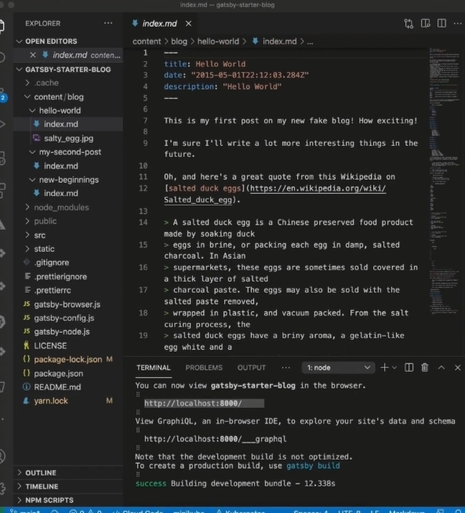

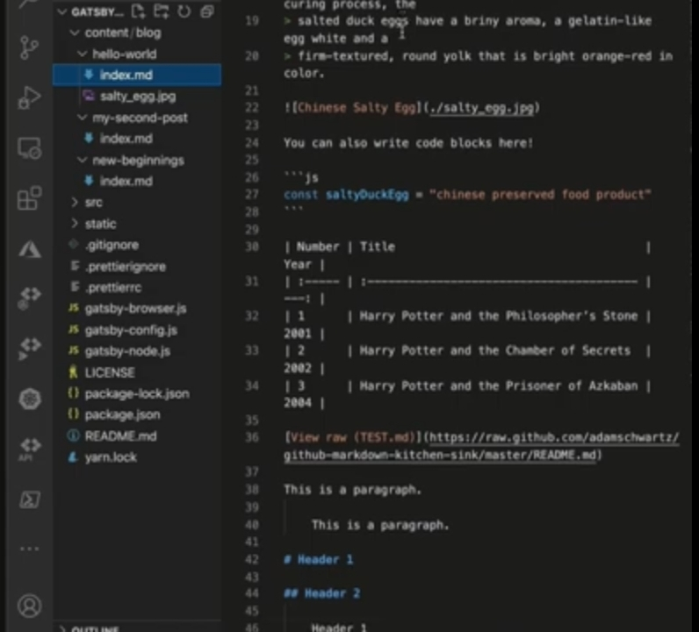

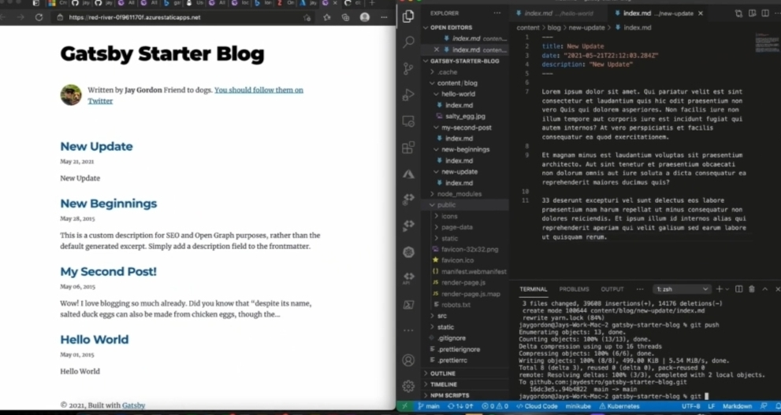

In this personal blog, we have run the code to create a webpage as Well as travel to one webpage to another webpage in website.

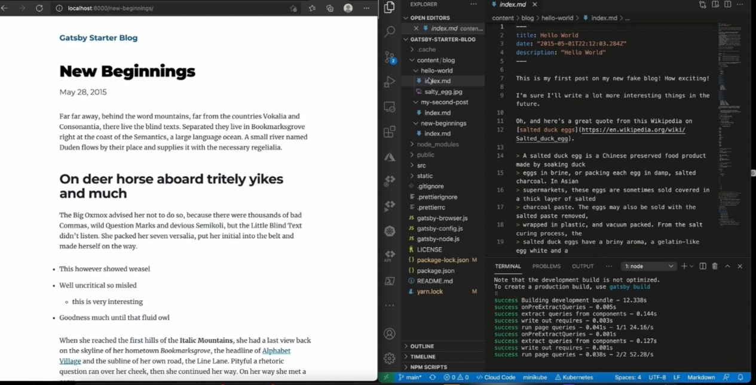

Model Building:

To build the model by using IBM cloud login after press the search a resource name is object storage.

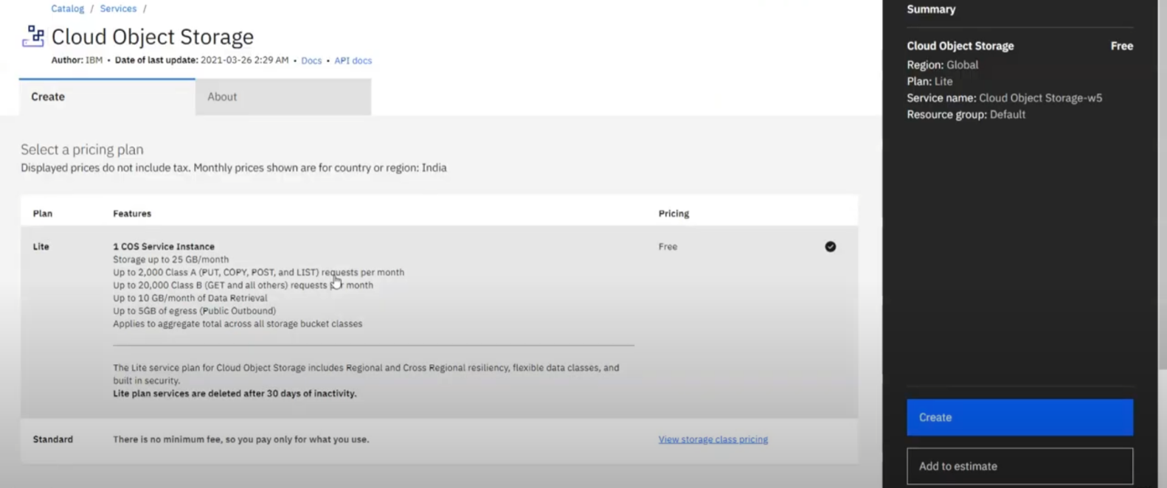

Deploying:

Hosting a static website on IBM cloud object storage starts with Creating a bucket and configuring it for public access.To press the create button then goes to after page is see to below:

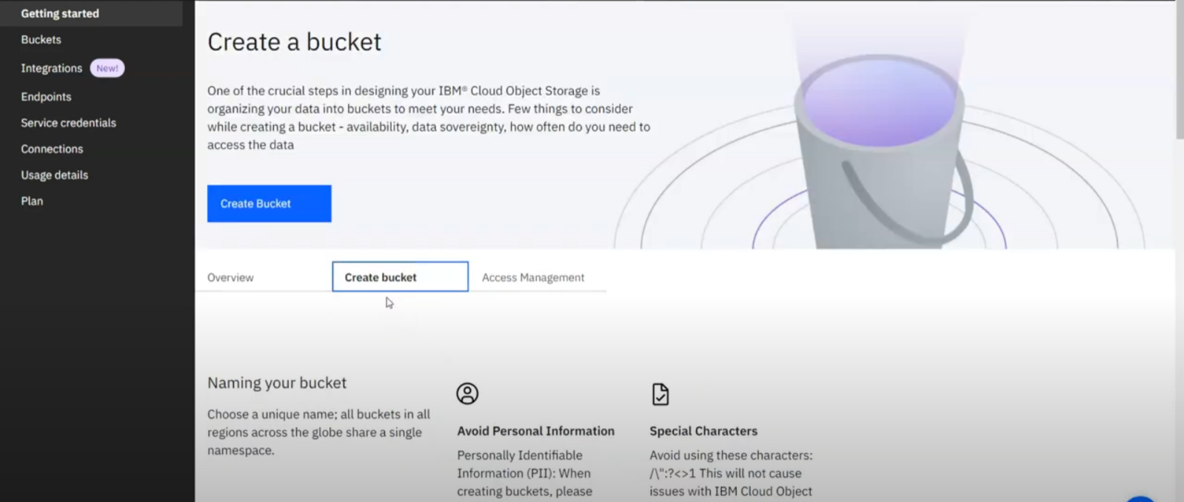

To press the create bucket button then displaying create a bucket below to press the customize options .

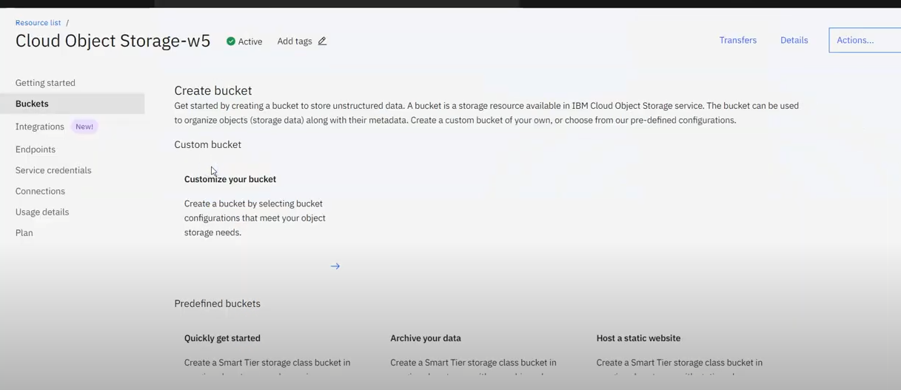

To press the arrow then goes to page and enter the information to custom the buckets like location and unique bucket name.

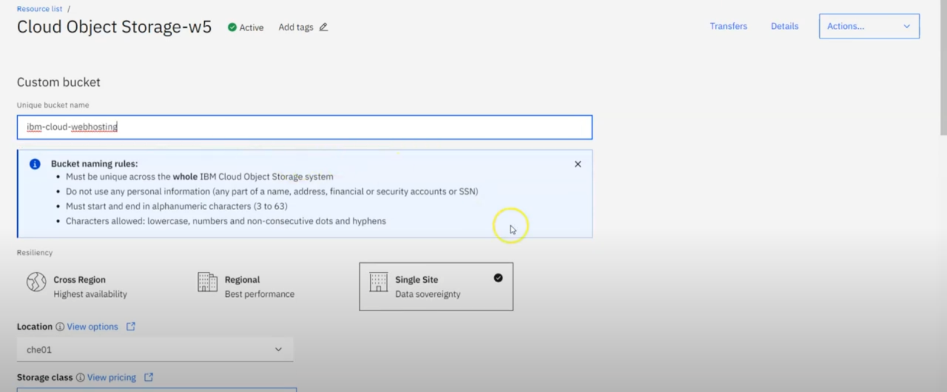

After click the below create bucket button then press the below drag or upload files link as well as select the files and upload it.

Uploading The files:

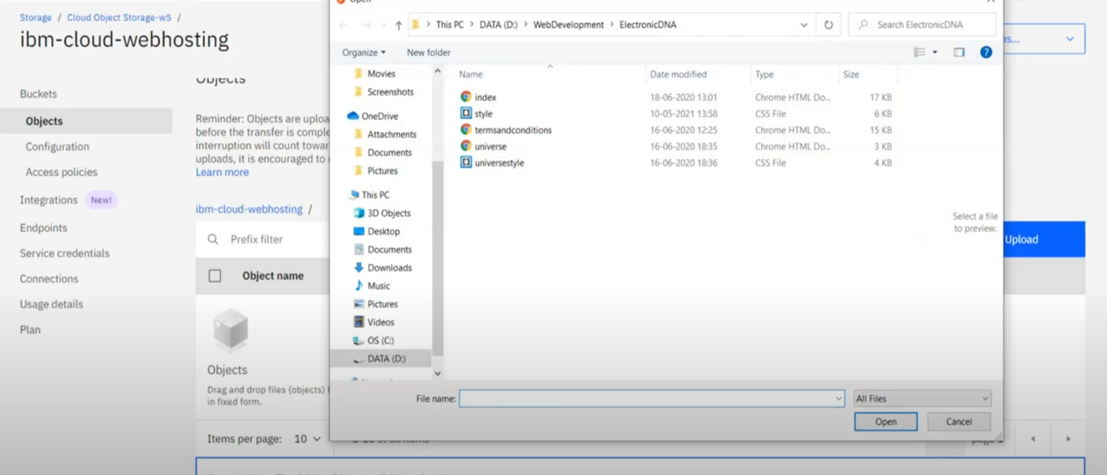

Code for one file can be viewed to below

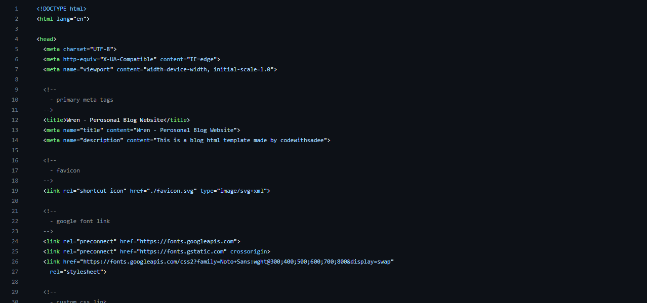

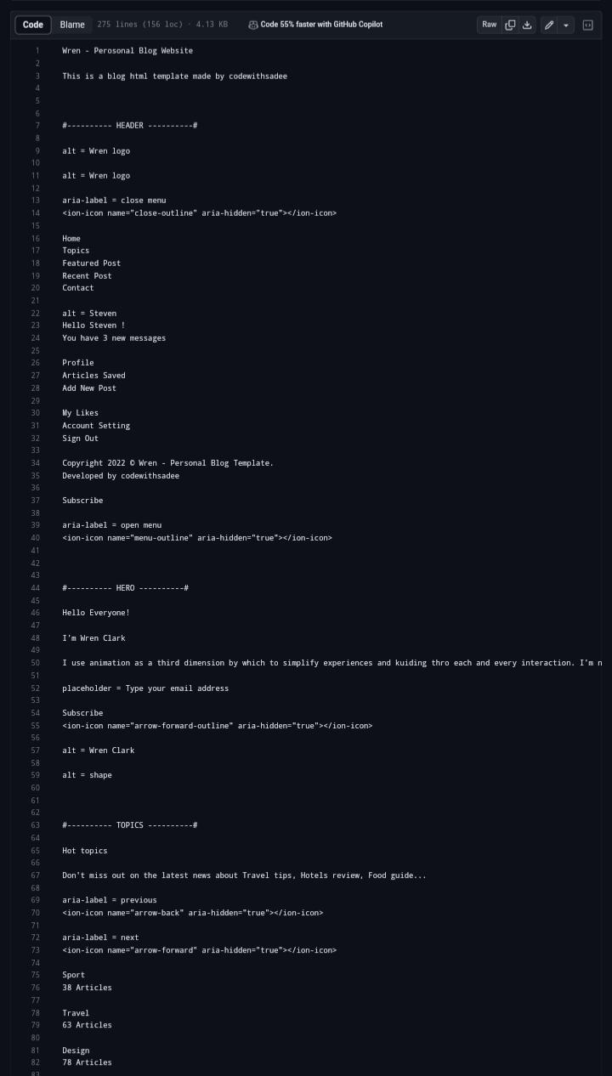

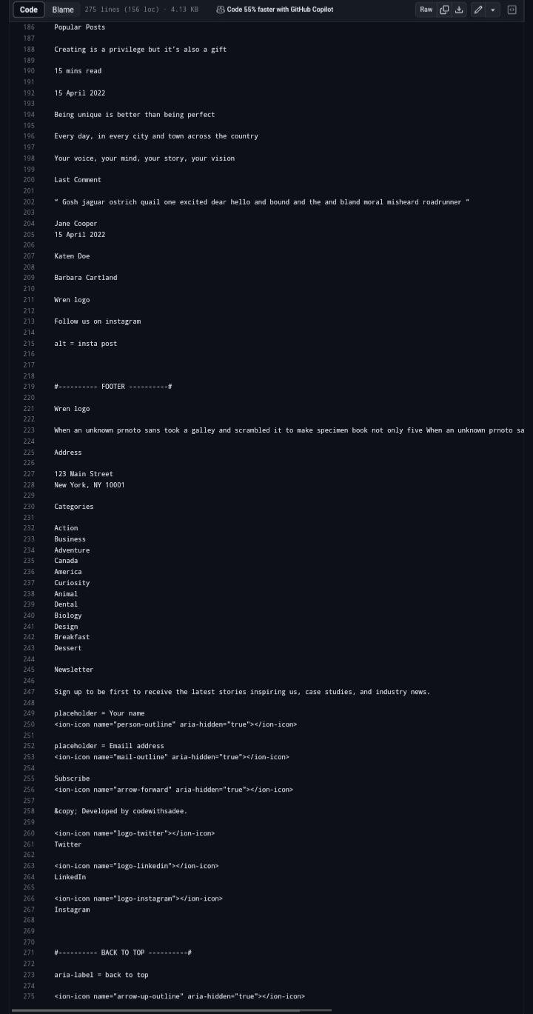

After update the bucket policies like public access is used to view the web page for anyone. To press the create access policy button as well as to select the enable button.

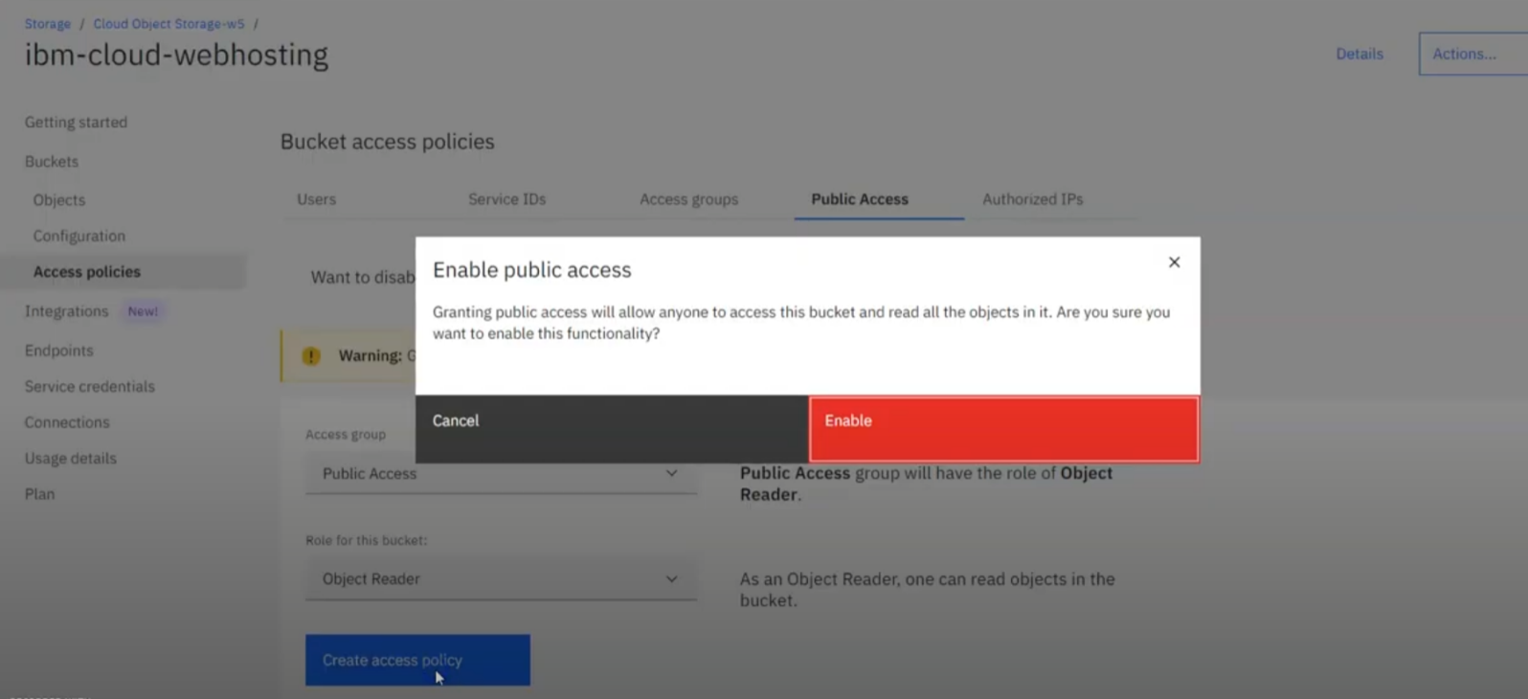

After copy the object public URL of upload files go to objects option as soon as possible to the create a webpages can be viewed.

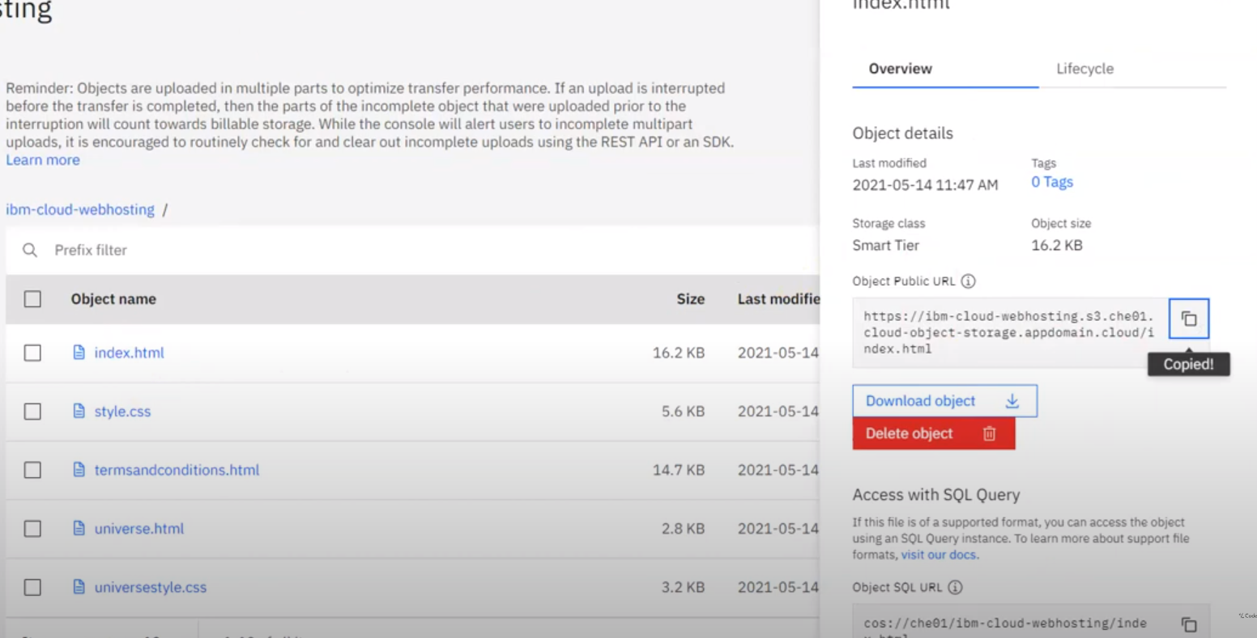

Output:

To paste the URL in google chrome and view the webpage or your output.

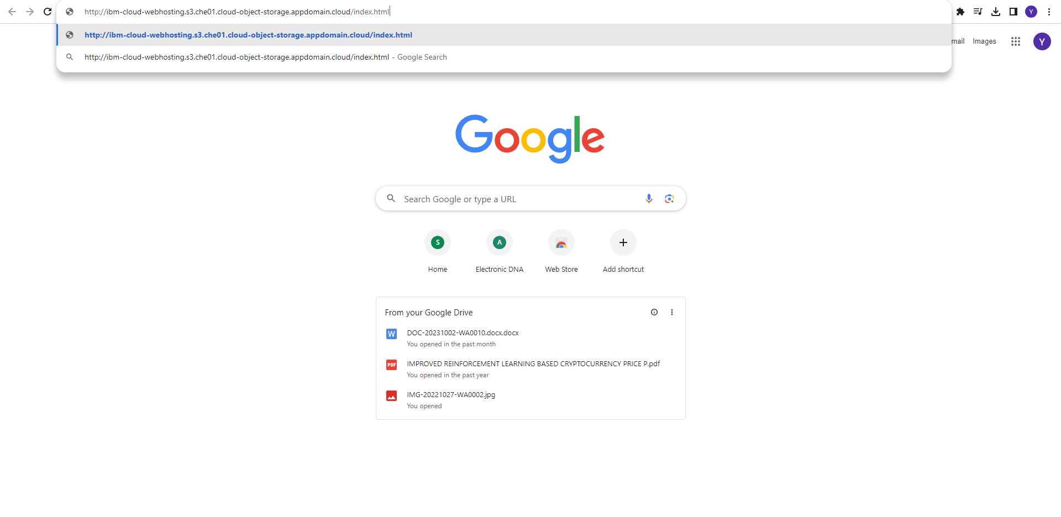

This is output for a travel blog with IBM cloud static web apps as well as creating a IBM cloud account setting up a static web apps and selecting a static site generator.

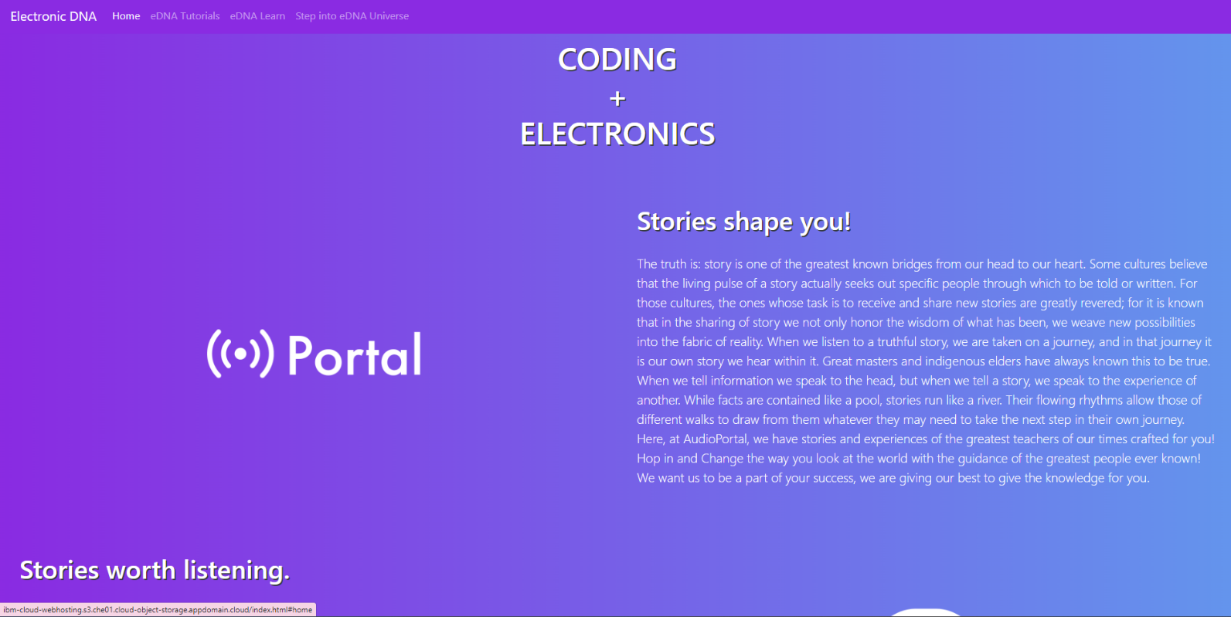

This is scroll down the website is see to below

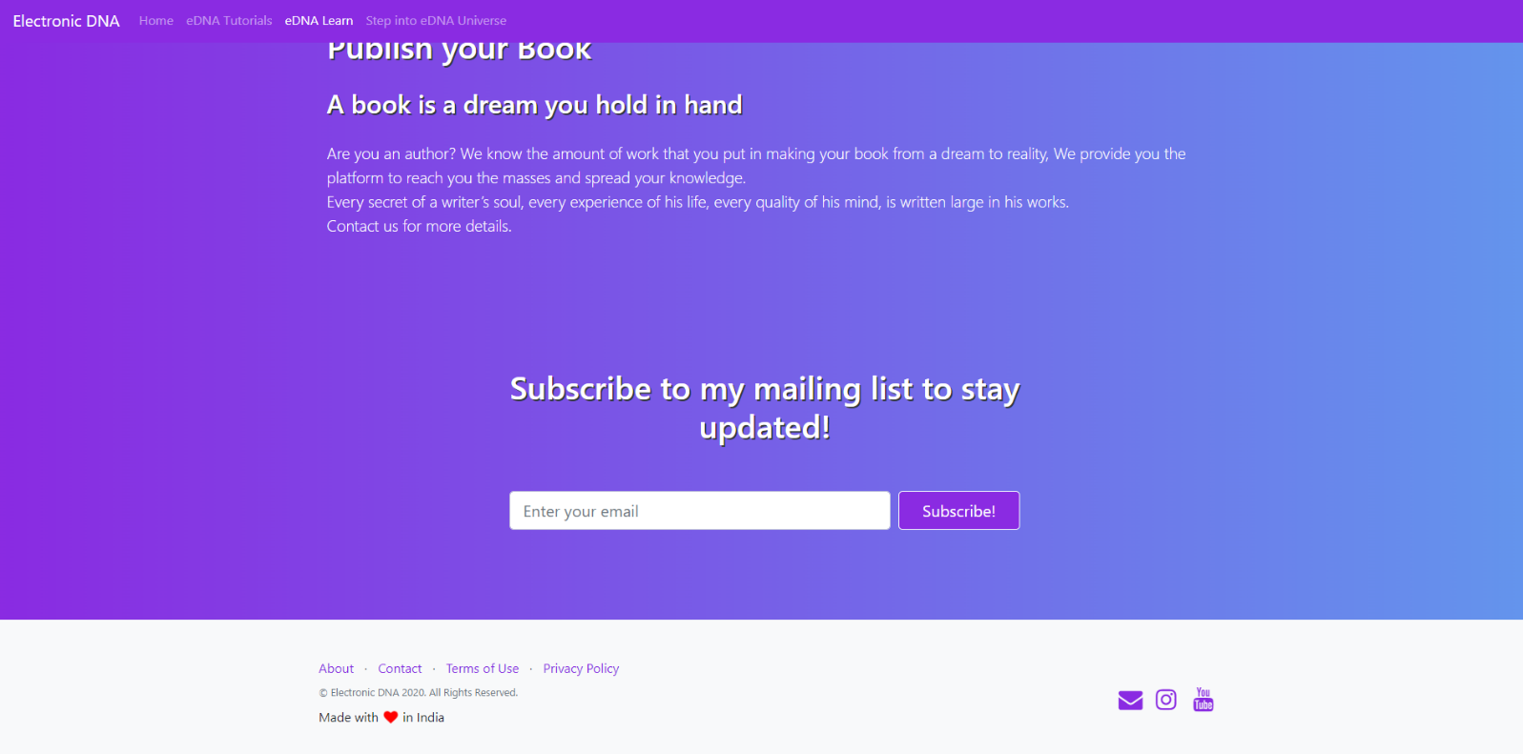

Conclusion:

In this conclusion ,To setting up a personal blog on IBM cloud static web apps is straightforward and efficient way to host and manage the blog. To setting up a travel blog with IBM cloud static web apps and creating a IBM cloud account setting up a static web apps and choosing a static site generator.